**Js DOM**

**Alzero Videos(68-101)**

DOM? When the browser load the html page it automatically create an object model name as Document object theis object contain all the html page element as tree structure and the root of it named document .in js we can use this documeny object to crete new html elemnt in the page or remove element ,update content ,ets …..

## DOM selector

## get/set element content and Attributes A screenshot of a computer

AI-generated content may be incorrect.

If the attribute not exist it will add it to the html element

innerHtml => assign html code فهي تلقائيا حتفهم انو هاد كود html

textcontent => assign text content فلو كتبت كود

html

ما حتفهمه وتعتبره نص عادي

في دوال لارجاع او التعديل على

Attributes

Set,get

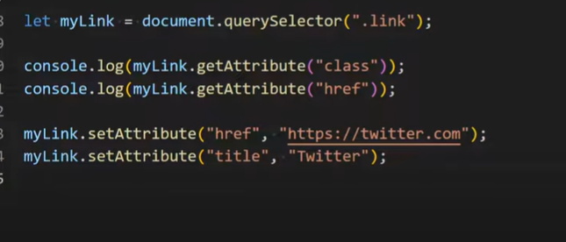

###check attributes

##Crete element

##Dom deal with children

Children => return only the Element html children

childNodes =>return the Element html children ,comments and text

firstchild=>return the first child regardless of his type is text or element.

lastchild=>return the last child regardless of his type is text or element.

firstElementChild=>return the first html elements not text or comments

lastElementChild=>return the last html element not text or comments

## DOM Events

Events:

كل( (actions

اللي ممكن يعملها اليوزر في الصفحة مثلا لما يضغط على الماوس اسم الحدث onclick

لما يعمل refresh page هاد الحدث اسمه onload

Ex1:

Ex2:

Ex:

##Events simulation

بتعمل محاكات للايفنتتس لكن مش انا كيوزر اللي بعملها

مثلا لما يتم عمل load for page

بدنا المؤشر يعمل فوكس فب ال

Input field الثاني

في الفورم نستخدم

focus()

##class list

Add one class or more to listclass by using add method

Remove one class or more from list class by using remove() method

Toggle() =>toggle will remove the class if the class already exist in the classlist else will add the class to the classlist

هو بيعمل

Add or remove

حسب اذا الكلاس موجود باللست او لء

##

##css style

To update,add,remove a style property there's more than way in inline style and external style

1-style

2-cssText

3-method as setProperty(),removeProperty()

لكن في شغلة بسيطة بتختلف بين ال

Inline style,external style

انو كيف بوصل للستايل

1. Inline style =>

بوصله مباشرة من

Document

1. External style file

documrnt.stylesheets[0] => the first style file wich contains array of rules(element in css style file) object

rules[0]=>the first style element



##deal with element

1-before() => add element before the selected element

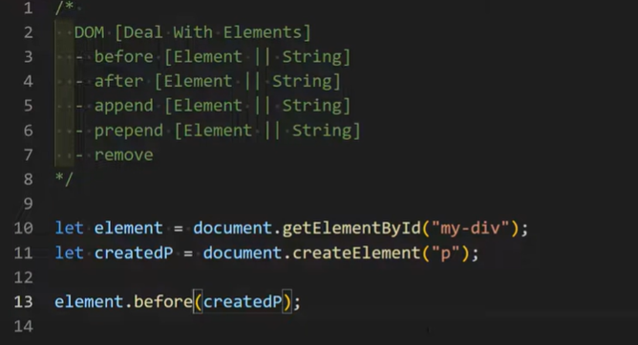

2-after () => add element before the selected element

3-apppend () => add element in end the selected element

3- prepend () => add element in start (first)the selected element

بتحط العنصر الجديد داخل العنصر اللي ماسكينه باوله –

##Traversing (الانتقال بين الاشقاء والانتقال للاب )

1-nextSibling()=>move to the next siblinig of the current selected element

In the bove example the next sbiling is the comment

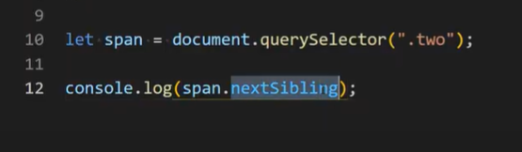

2-nextElementSibling()=>move to the next Element siblinig of the current selected element

In the bove example the next Element sbiling is the span with class three (بما انو بدو الششقيق التالي من نوع اليمينت اذا حيتجااهل التعليق واي تكست موجود)

3-previousSibling()=>move to the next siblinig of the current selected element

In the bove example the prev sbiling is the comment

4-previousElementSibling()=>move to the prev Element siblinig of the current selected element

In the bove example the prev Element sbiling is the span with class one (بما انو بدو الششقيق التالي من نوع اليمينت اذا حيتجااهل التعليق واي تكست موجود)

5-parentElement ()=>move to the parent Element of the current selected element

Ex:

when click on the span two make the parent div not display

## cloning(الاستنساخ)

Create copy of an element to use it in more than one place in the html page

Ex:

لو مثلا بنا ننشأ فقرة داخل ال

Div

نفس الفقرة اللي ب

بدون ما نأثر على الفقرة الاصلية كيف ؟body

cloneNode()=>take false by default or true

a-false or empty =>means make copy of the selected element only with his attribute and style and any thinks or element inside it will not copied.

Ex :

هون بتم نسخ الفقرة فقط والاتربت اللي فيها ولكن ما بينسخ اللي جواها من

Span , text ets ..

b-true =>means make copy of the selected element his attribute and style and any thinks or element inside it will copied.

Ex :

هون بتم نسخ الفقرة والاتربت اللي فيها وكل العناصر اللي جواها اللي جواها من

Span , text ets ..

